**STAFF WORK AND PERFORMANCE EVALUATION AND MONITORING SYSTEM**

**A SYSTEM RESEARCH PROPOSAL**

**SUBMITTED BY,**

**EVANS MUTWII**

**DIT-01-8333/2021**

**A RESEARCH PROPOSAL SUBMITTED IN PARTIAL FULFILMENT FOR THE AWARD OF A DIPLOMA IN INFORMATION TECHNOLOGY BY ZETECH UNIVERSITY**

**JULY 2022**

Table of Contents

**DECLARATION** i

**ACKNOWLEDGEMENT** ii

**DEFINITION OF KEY TERMS** iii

**ABBREVIATIONS AND ACRONYMS** iv

**ABSTRACT** v

**LIST OF FIGURES** vi

**LIST OF TABLES** vii

**CHAPTER ONE: RESEARCH INTRODUCTION** 1

**1.1** **Research problem** 1

**1.2** **Research Objectives** 1

**1.2.1** **General Objective** 1

**1.2.2** **Specific Objectives** 1

**1.3** **Background Information** 1

**1.4** **Study Justification** 2

**1.5** **Study Limitation** 2

**1.6** **Problem Scope** 2

**CHAPTER TWO: LITERATURE REVIEW** 3

**2.1 Introduction** 3

**2.2 Theoretical Review** 3

**2.3 Empirical Review** 4

**CHAPTER THREE: SYSTEM METHODOLOGY AND DATA COLLECTION** 7

**3.1 Introduction** 7

**3.2 System Requirements Specification** 7

**3.2.1 Functional Requirements** 7

**3.2.2 Non-Functional Requirements** 7

**3.3. Design** 7

**3.4.1 Language(s), Frameworks and Other Technical Requirements** 21

**3.4.2 Code Review Strategy** 21

**3.5 Testing** 21

**3.5.1 Functional Requirements Testing** 21

**3.5.2 Non-Functional Requirements Testing** 22

**3.6 Deployment** 22

**CHAPTER FOUR: CONCLUSION AND RECOMMENDATIONS** 23

**4.1 CONCLUSION** 23

**4.2 RECOMMENDATIONS** 23

**CHAPTER FIVE: REFERENCES AND APPENDICES** 24

**5.1 REFERENCES** 24

**5.2 APPENDIX I:** 24

**5.3 APPENDIX II:** 24

# **DECLARATION**

I certify that this proposal is my own work and has not been presented for any other party

No part of this of this research should be reproduced without my consent or that of Zetech University

Student Signature………………………... Date…………………………

Supervisors Signature…………………… Date………………………….

# **ACKNOWLEDGEMENT**

The completion of this proposal could be possible without the support from the following people. First and foremost I would like to thank my supervisor Mr. Isaac Nyamongo for the guidance throughout this task. Secondly I would like to thank my friends for encouraging me whenever I thought of giving up on this task. I would like to thank Zetech University for offering a good environment and resources for me to carry out this task

Above all, I would like to give thanks to the Almighty God, the author of knowledge and wisdom for his grace and mercies.

# **DEFINITION OF KEY TERMS**

**Problem scope-t**he boundaries within which the research project will be performed

**Study justification-**reason why the study is being conducted

**Theoretical review -a** literature review basing on theory that already exist

**Empirical review-**a literature review basing on observed and measured phenomena

**Personnel**-is the people work for an organization

**SQL**- Structured query language is a relational database language used to define, manipulate, search, update and retrieve data in the database

**Database**- A collection of operational data of organization stored in related tables

**Information**- this is a processed data / facts obtained by assembling them into meaning form

**Program-** Is a set of coded instructions written in any of the programming languages to perform a specific task

**Updating-** this is the process of modifying the master file or changing the master file by altering records to show the current data

**Sorting**- is the operations of arranging the records of table or listing into sequential order according to ordering criteria

**Searching**- This is the process of looking for a particular record in a list and it is daily operation in the record documentation

# **ABBREVIATIONS AND ACRONYMS**

PMS-performance monitoring system

IT-Information technology

DFD -Data flow diagram

# **ABSTRACT**

Chapter one: A management system is very essential and key in institutions for better service delivery employers can monitor the performance of their employees so as ensure accountability and good service delivery. There is limited attention on how to monitor staff work and evaluating their performance in Kenya by employment stakeholders. There is no clear understanding on to how there is poor performance and poor service delivery within them

This study indents to investigate factors that influence poor service delivery by staff in companies and how to come up with an efficient PMS

Chapter two: This chapter covers the analysis of existing literature by other researchers on this topic. It involves findings by other researchers. The literature review is organized based on themes and variables under study. It further provides a theoretical & conceptual framework. Three factors of higher rating between performance ratings and salary increases are discussed that weakened over the three-cycle rating period also the benefits of assessment in an organization.

Chapter three: This chapter contains a discussion of various components of the research as will be applied in the study. They include design program, target population sample procedures and methods of data collection. A comprehensive study is carried out on old manual system so as to surface with the relevant facts that can help in designing of new one. The key methods for collecting data are interview method, record method, and observation method. The program structure shall have five modules such as: Main module, Registration module, Login module and Assessment module.

# **LIST OF FIGURES**

Fig 1. low level design

Fig 2. High level design

Fig 3. Diagram showing Registration page flowchart

Fig 4. Diagram showing fill out Registration form.

Fig 5. Diagram showing Appraisal form.

Fig 6. Diagram showing Admin platform

# **LIST OF TABLES**

Table 1. Employee Design

Table 2. Criteria Design

Table 3. Assessment Design

Table 4. GANTT CHART

# **CHAPTER ONE: RESEARCH INTRODUCTION**

## **Research problem**

Institutions use both manual and automated performance management system to evaluate employees. However, most of them does not gauge effectiveness and efficiency of each staff’s effort. Most companies are giving clients assurance of an effective solutions for better service delivery unfortunately they won’t be able to keep this assurance

Poor service delivery by staff to clients will impact the company negatively. The staff may be under-performing across multiple spreadsheet can be a difficult task.

Data reporting is a big issue because running reports across multiple spreadsheet can be a difficult task.

## **Research Objectives**

### **General Objective**

* To determine how PMS can improve performance of staff

### **Specific Objectives**

* To establish a mechanism to take into record the time staff report to work
* How to come up with a software app for customer response and feedback
* Way to set up remote access programs to observe staff work
* Coming up with self-monitoring tools for staff like online project plans, checklists and activity logs

## **Background Information**

Every organization seeks to improve performance and good service delivery but it can never be conceivable without the efficient and effectiveness of performance of its staff. As a result they seek to come up with a PMS to address these concerns

The PMS will involve creating clear prospects and understanding around job role and responsibilities for each staff and to also establish how staff and controller can work together to sustain, improve performance

Hence, the perseverance of this study focuses on investigating how to come up with elaborate PMS and extend of its effectiveness

## **Study Justification**

There arise need to carry out this study for various reason. The company seeks to solve various challenges after this proposed research. For accountability and good service delivery by staff ,a system has to be developed so as to monitor how the staff work and how each of them perform . This study indents to find out how to an elaborate system can be developed

## **Study Limitation**

The study is likely to be affected by financial constraints because as a researcher I am self-sponsored however to overcome this people of good will be engaged so as to offer financial aid. Respondents may be unwilling to give answers or even their and to avoid this a good rapport has to be established between the researcher and the respondents. Time for carrying out this study is limited as the researcher has got other personal engagements. To overcome this a researcher will have to maximize any time available.

## **Problem Scope**

This study focus on how employee performance can be measured and their work rated so as to boost the productivity of the company

# **CHAPTER TWO: LITERATURE REVIEW**

## **2.1 Introduction**

The purpose of this chapter is to review and discuss human resource management and human resource performance evaluation in general local government. Local authorities have her one or more individuals who are responsible for managing the welfare and performance of everyone within the local government organization. This task of overseeing programs and setting policies that affect everyone associated with an organization is called Human Resources Management. Sometimes referred to as human resource (HR) management. The HR Manager role usually begins with the hiring process. He or she may focus on screening and interviewing applicants to place people with the right skills in the right positions within the organization. The HR manager may also oversee or at least be involved in the creation of entry-level training programs and continuing education opportunities for employees already working for the company. Personnel evaluation in local government is a systematic process by which local governments engage employees as individuals and as members of groups to improve their effectiveness in accomplishing tasks and goals. Performance Monitoring

* Increase Efficiency
* Evaluate Performance and
* Reward Good Performance

During the global economic crisis, almost all public and private organizations suffer from some form of performance problem. This chapter has detailed various aspects of performance management. Many researchers and experts assert that sets of guidelines for design of performance management systems would lead to high performance (Kaplan and Norton, 1996, 2006). A long time ago, the traditional performance measurement was developed from cost and management accounting and such purely financial perspective of performance measures was perceived to be inappropriate so that multi-dimensional performance management was development in the 1970s (Radnor and McGuire, 2004). In fact, the term “performance management” was not utilized until the 1970s (Armstrong and Baron, 2005). Since then, the language of performance has become an almost every-day feature of work in many organizations, in some form or another and the language of performance has been associated with the establishment of standards or indicators to be achieved, and the audit of organizational systems to ensure conformance (Boland and Fowler, 2000). In general, personnel management includes activities that ensure that organizational goals are consistently being met in an effective and efficient manner so that it involves shared vision, management style, employee involvement, incentives and rewards, competence framework, team work, education and training, attitudes, and dialogue

## **2.2 Theoretical Review**

The major technologies used in this project are Web technologies (HTML, PHP, CSS, SQL). The site developed is a collection of web documents and is presented to the user by an application program known as a browser (example internet explorer, Firefox etc.).

Hyper Text Markup Language, commonly referred to as HTML, is the standard markup language used to create web pages. It is written in the form of HTML elements consisting of tags enclosed in angle brackets (like <html>). HTML tags most commonly come in pairs like <h1> and </h1>, although some tags represent empty elements and so are unpaired, for example <imp>. The first tag in a pair is the start tag, and the second tag is the end tag (they are also called opening tags and closing tags). Web browsers can read HTML files and compose them into visible or audible web pages. Browsers do not display the HTML tags and scripts, but use them to interpret the content of the page. HTML describes the structure of a website systematically along with cues for presentation, making it a markup language, rather than a programming language. HTML elements form the building blocks of all websites. HTML allows images and objects to be embedded and can be used to create interactive forms. It provides a means to create structured documents by denoting structural semantics for text such as headings, paragraphs, lists, links, quotes and other items. It can embed scripts written in languages such as JavaScript which affect the behavior of HTML web pages.

PHP is a programming language that can do all sorts of things: evaluate form data sent from a browser, build custom web content to serve the browser, talk to a database, and even send and receive cookies.

A CSS (cascading style sheet) file allows you to separate your web sites HTML content from its style. As always you use your HTML file to arrange the content, but all of the presentation (fonts, colors, background, borders, text formatting, link effects & so on…) are accomplished within a CSS. At this

</head>

<body>

With this method each HTML file contains the CSS code needed to style the page. Meaning that any changes you want to make to one page will have to be made to all. This method can be good if you need to style only one page, or if you want different pages to have varying styles.

SQL (pronounce") stands for Structured Query Language. SQL is used to communicate with a. SQL statements are used to perform tasks such as update data on a database, or retrieve data from a database. Some common relational database management systems that use SQL are: Oracle, Sybase, Microsoft SQL Server, Access, Ingres, etc. Although most database systems use SQL, most of them also have their own additional proprietary extensions that are usually only used on their system. However, the standard SQL commands such as "Select", "Insert", "Update", "Delete", "Create", and "Drop" can be used to accomplish almost everything that one needs to do with a database.

## **2.3 Empirical Review**

The extent of the literature on personnel performance Assessment in management indicates its importance both in the private techniques, and specific case studies. There are few empirical studies documenting the personnel performance Assessment practices used by local government. Given the scarcity and in the public sector. Much of the literature deals with how-to-do-it articles, specific Assessment of personnel performance Assessment studies, in this work have also been included some discussion of research on management by objectives (MBO), a management technique closely related to personnel performance Assessment, at the local level.

Studies in (Lachs, Stearns, and Villere,2000) examined the Assessment practices of the sixty largest cities in the United States. The findings showed that 72 percent of the cities had a performance Assessment system in place. The primary purposes of Assessment were rewards, raises, and promotions as opposed to development and training needs. The major method was the graphic rating scale combined with essay (68 percent). The typical employee Assessment systems and forms were poorly designed. They were not job related, and they used poorly defined job factors and performance levels.

Performance Assessment is “the process of identifying, observing, measuring, and developing human performance in organization” this definition is very important, because it comprises all important components needed for the well performed Assessment process. Identification of criteria orientate the Assessment process to the determination of comes”. It is often said that organizations that perform well are a reflection of the efforts and successes of their staff. Recognizing these efforts and appropriately praising or redirecting them is imperative for organizational success. This is the basic purpose of performance Assessments (Carroll and Schneider, 2001).

The finding in (Ammons, David, and Rodriguez, 2003), shows MBO was used for the council-manager and mayor- council forms of government. In addition, MBO was used citywide in 35 percent of the cases and in selected areas in 30 percent of the cases. It had been attempted but discontinued for 5 percent of the cities. MBO, a centralized planning and control device had significantly greater use in citywide applications.

A study that examines the distribution of performance ratings and pay increases after the completion of three rating cycles (Allan and Rosenberg, 1986). The findings indicated a discernible trend toward an escalation in above-average performance ratings. In addition, the relationship between performance ratings and salary increases weakened over the three-cycle rating period. The higher ratings were felt to be due to three factors

* The desire to recognize the employee's performance
* The fact that since funds for merit increases were limited, performance could be rewarded only if it received a higher rating
* The desire to avoid confrontation with the employee.

Research examined the Assessment practices of upper management personnel in 122 U.S. cities with Lachs. Stearns and Whelan 1980 populations of 65,000 or more. It was found that 59 percent of these local governments had formal, documented Assessment systems. The most common objective of Assessment was to provide employee feedback (60 percent). The allocation of rewards ranked second (24 percent). The use of MBO was predominant. Some 35 percent used MBO alone; 65 percent used MBO plus other techniques. The use of MBO was more common in cities with formal Assessment systems and council-manager forms of government. A major concern was the extremely modest amount of executive and staff time devoted to the Assessment process (Ammons, David, and Rodriguez, 2003).

Also says that the primary objective of Assessment was employee feedback (54 percent), allocation of rewards (27 percent), and identification of skill deficiencies (9 percent). These findings were similar to those of (Ammons, David, and Rodriguez, 2003). Rating scales were found to be the method of evaluating employees most often used (74 percent). This method was used for cities of all sizes. The city-manager form of government was more likely to use an MBO system or MBO in combination with another technique. (England, Robert, and Parle, 1987) Shows that more time was taken in the Assessment process than (Ammons, David, and Rodriguez, 2003), had shown. However, this was felt to be a function of the increased number of employees rather than of quality Assessment time.

Performance Assessment is an evaluation of current performance or effectiveness against the key objectives using the measurement as the basis for factual evidence. (Chukwuemeka, 2004) Includes that performance evaluation should be able to establish the areas and priorities of deficiency and analyze their causes and proper possible remedies. The research also put forward that in the private administration, Assessment for performance is based on earned profit, but in the public administration, it is always subjective.

Assessment helps management of an organization in four different ways

* It helps the management decide on what increase of pay shall be given on grounds of merit.
* It helps the management to determine the future use of employee e.g., whether he/she shall remain in his or her present job or be transferred, promoted, demoted or dismissed.
* It indicates training needs in the organization that is area of performance where improvements would occur if appropriate training could be given.
* It motivates the employee to do better in his/her present job by giving him knowledge of result recognition of his/her merits and more, the opportunities to discuss his/her work with the manager (Gallomania, 2007).

# **CHAPTER THREE: SYSTEM METHODOLOGY AND DATA COLLECTION**

## 

## **3.1 Introduction**

This chapter contains a discussion of various components of the research as will be applied in the study. They include design, target population sample procedures and methods of data collection

## **3.2 System Requirements Specification**

### **3.2.1 Functional Requirements**

The following are the desired functionality of the new system

* Allow administrators monitor reporting data of staff on bio -metrics
* The system should carry out audit tracking
* The system will contain staff personal details

### **3.2.2 Non-Functional Requirements**

* The system must verify and validate all user data
* The system only allows the adminstrator to delete records

## **3.3. Design**

**3.3.1 Low Level Design**

Identify the problem problem

Requirement gathering

Definition

Design

coding

testing

Deployment

Maintainance

Fig 1. Low Level Design

**3.3.****1.1. Program Design**

The program structure has five modules such as:

* Main Module.
* Registration Module
* Login Module.
* Assessment Module.

**3.3.1.2. Modularity**

**Main Module**

The main module is the main program where all other modules are initiated.

**Registration Module**

This module takes care of staff registration on the website where they will specify their username and password.

**Login Module**

This module provides an interface for login process. This is where staff will login to fill out the Assessment form.

**Assessment Module**

This module provides an interface for evaluation officer and head of department to evaluate the staff online and promote the staff online respectively.

**3.3.1.3. Logical Design**

The database that will hold information about the record is MySQL server. The database structure is specifying below.

**3.3.1.4.** **Employee Design**

|  |  |  |  |  |
| --- | --- | --- | --- | --- |
| **SN** | **FIELDNAME** | **DATA TYPE** | **SIZE** | **DESCRIPTION** |
| 1 | Name | Sting | 45 | Stores name |
| 2 | Dob | String | 30 | Stores date of birth |
| 3 | Qual | String | 20 | Stores qualification |
| 4 | Dept | string | 20 | Stores department |
| 5 | appoint date | date | 20 | Stores date of appointment |
| 6 | present date | date | 20 | Stores present date of employment |
| 7 | days absent | string | 10 | Stores number of days absent |
| 8 | present job | string | 20 | Stores present job |
| 9 | Dash | date | 20 | Stores date appointed substantive grade |
| 10 | course taken | string | 30 | Stores course taken |
| 11 | Antiglare | string | 30 | Stores acting arrangement |
| 12 | Unnamed | string | 25 | Stores username |
| 13 | Word | string | 25 | Stores password |

**Table 1.**

**3.3.1.5.** **Criteria Design**

|  |  |  |  |  |
| --- | --- | --- | --- | --- |
| **SN** | **FIELDNAME** | **DATA TYPE** | **SIZE** | **DESCRIPTION** |
| 1 | Criteria | Sting | 45 | Stores criteria id |
| 2 | Employee | String | 30 | Stores employee id |
| 3 | Employee name | String | 20 | Stores employee name |
| 4 | Foresight | string | 20 | Stores foresight |
| 5 | penetration | string | 20 | Stores penetration |
| 6 | Judgment | string | 20 | Stores judgment |

**Table 2.**

**3.3.1.6.** **Assessment Design**

|  |  |  |  |  |
| --- | --- | --- | --- | --- |
| **SN** | **FIELDNAME** | **DATA TYPE** | **SIZE** | **DESCRIPTION** |
| 1 | Assessment | String | 30 | Stores Assessment id |
| 2 | Criteria | String | 20 | Stores criteria id |
| 3 | criteria name | string | 20 | Stores criteria name |
| 4 | criteria score | string | 20 | Stores criteria score |

**Table 3.**

**3.3.1.7. Program Flowchart**

Main menu

1. Registration form
2. Login to fill form
3. Admin

Is Option 1 select?

Registration form

Is Option 2 select?

Is Option 3 select?

Yes

No

Fill Appraisal

No

Yes

Admin platform

No

Yes

Fig 3. Diagram showing Registration page flowchart

Registration form

Fill out registration form

Submit form

Fig 4. Diagram showing fill out Registration form.

Appraisal form

Username

Password

Fill appraisal form

Enter username and password

Are login details, correct?

No

Yes

Fig 5. Diagram showing Appraisal form.

Admin platform

Username

Password

Examine and appraised staff

Enter username and password

Are login details, correct?

No

Yes

Fig 6. Diagram showing Admin platform

**3.3.2 conceptual Design**

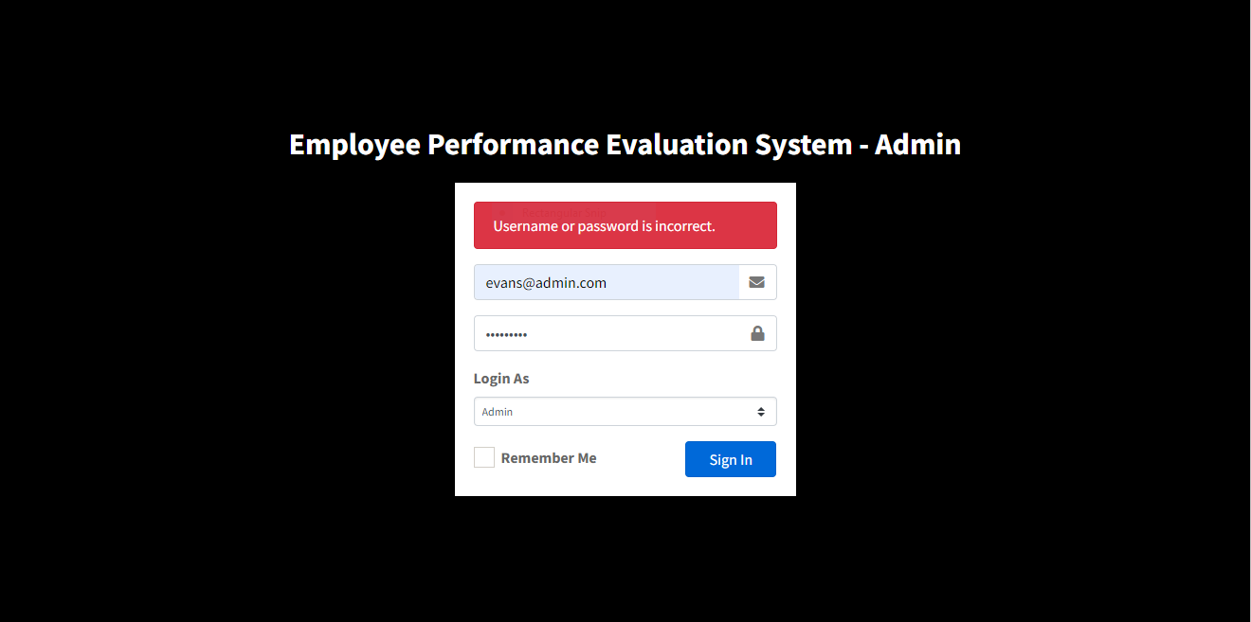

**3.3.2.1** Incorrect password

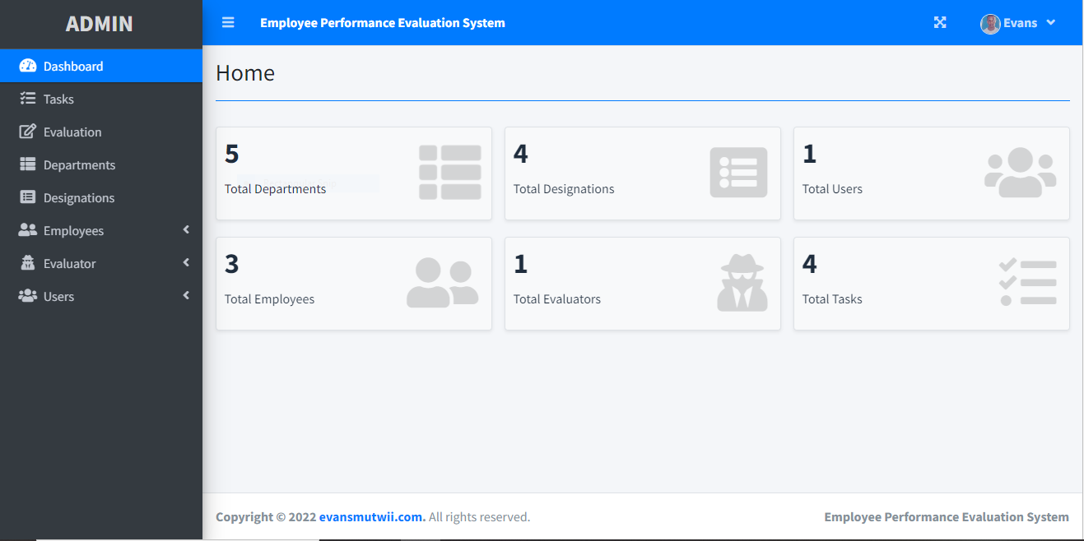

**3.3.2.2** Correct login and Admin Dashboard

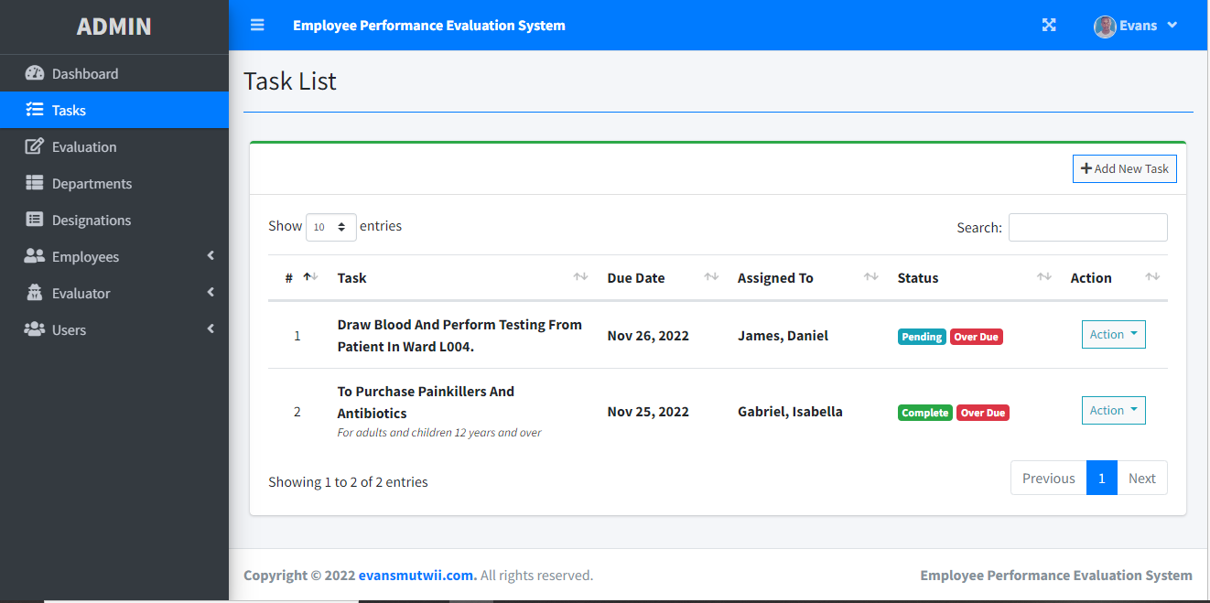

**3.3.2.3** Tasks issued by Admin

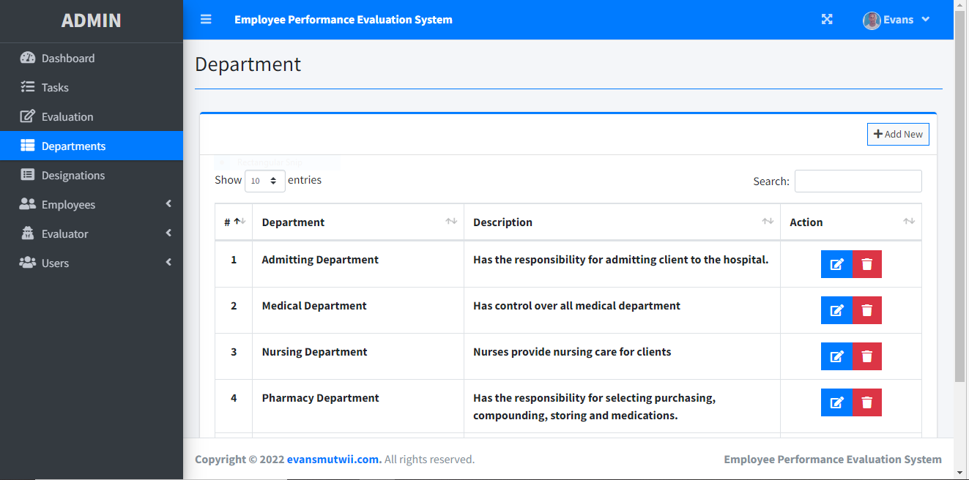

**3.3.2.4** Number of Departments

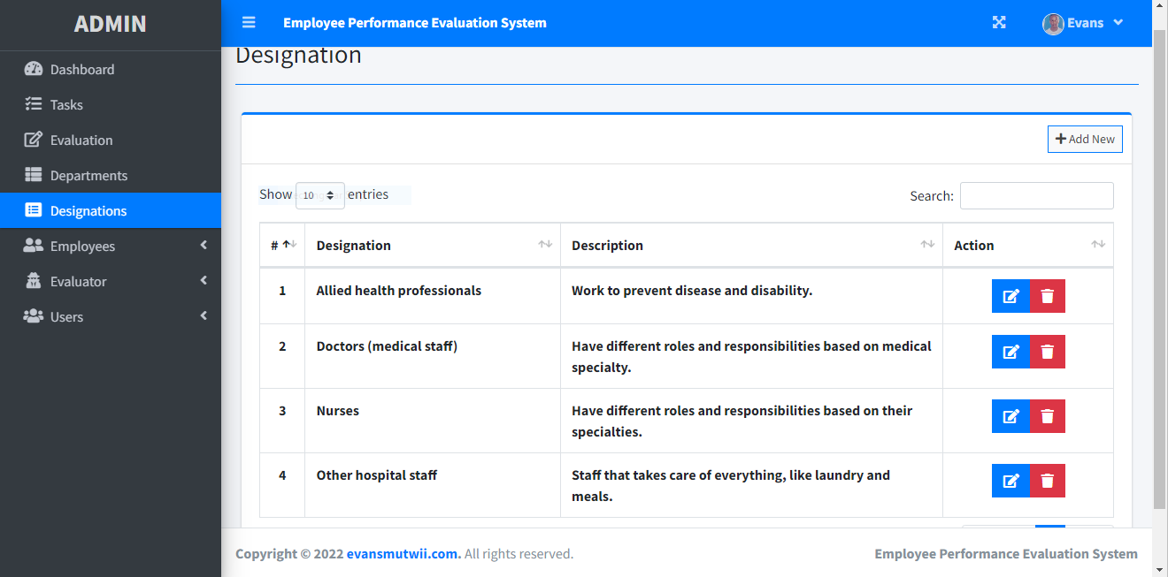

**3.3.2.5** Designations

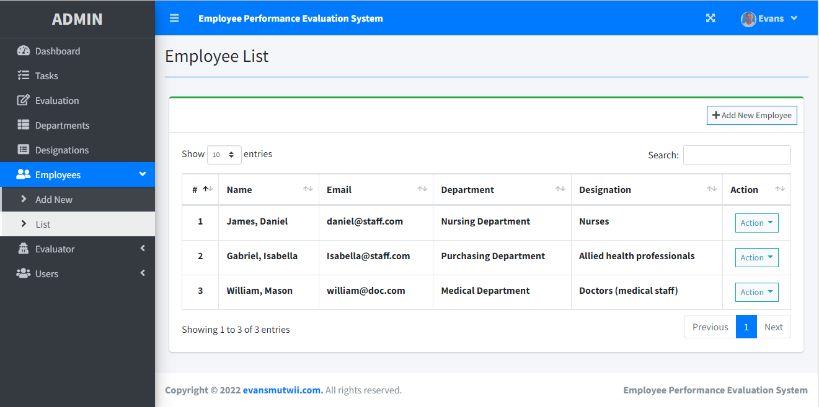

**3.3.2.6** List of Employees

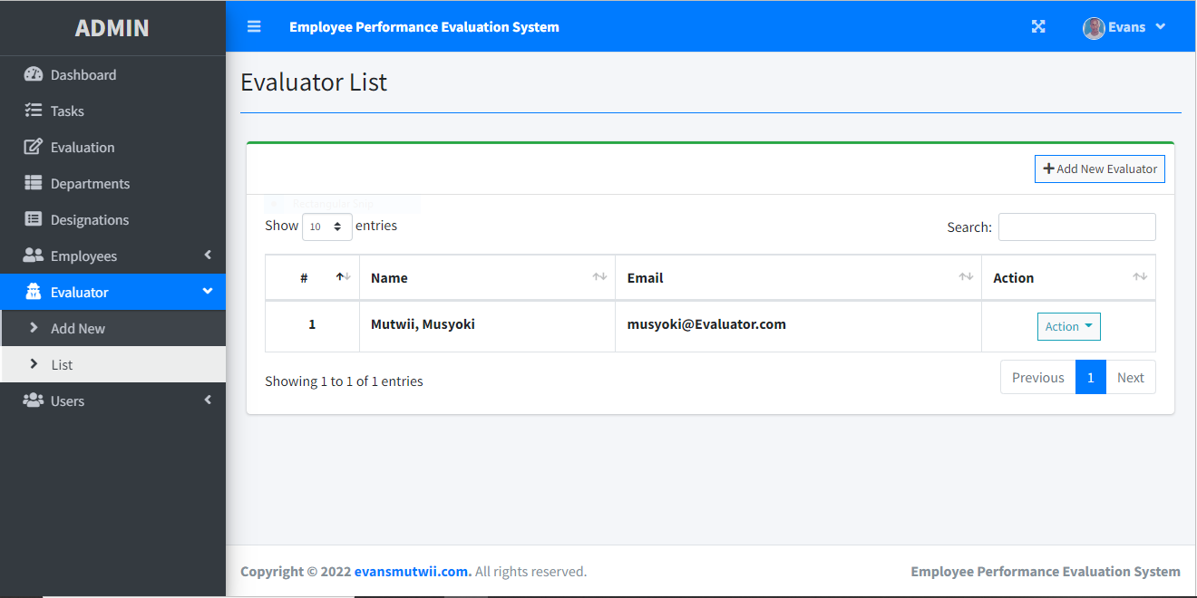

**3.3.2.7** Evaluator List

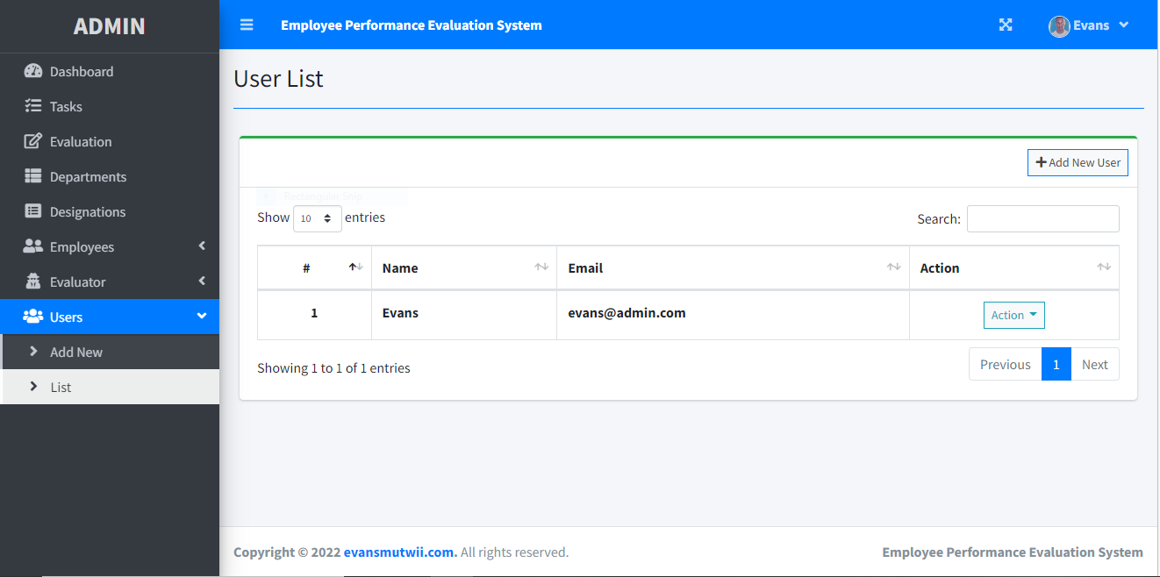

**3.3.2.8** List of Users

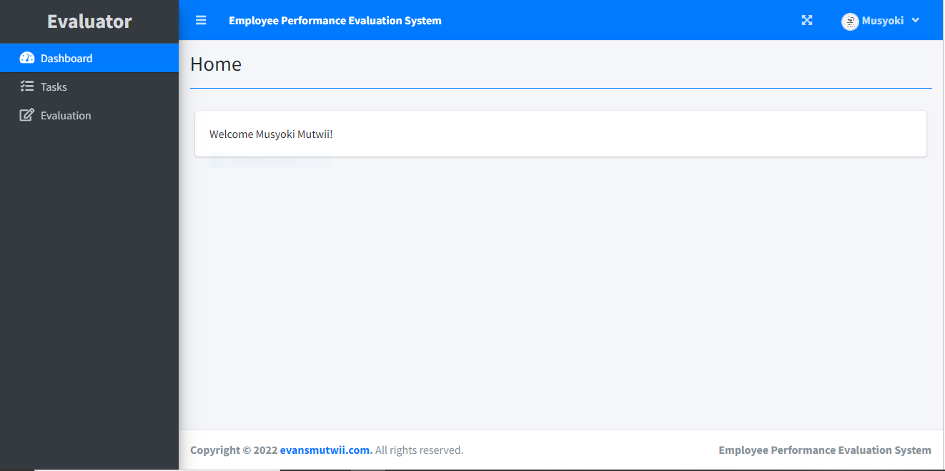

**3.3.2.9** Evaluator Dashboard

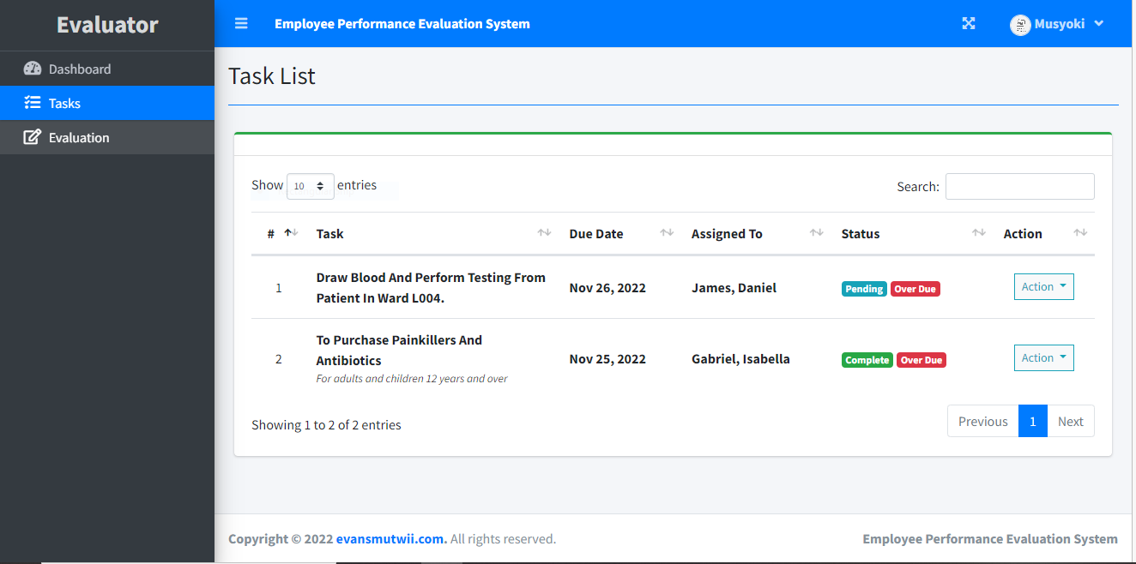

**3.3.3.1** Evaluator Task List

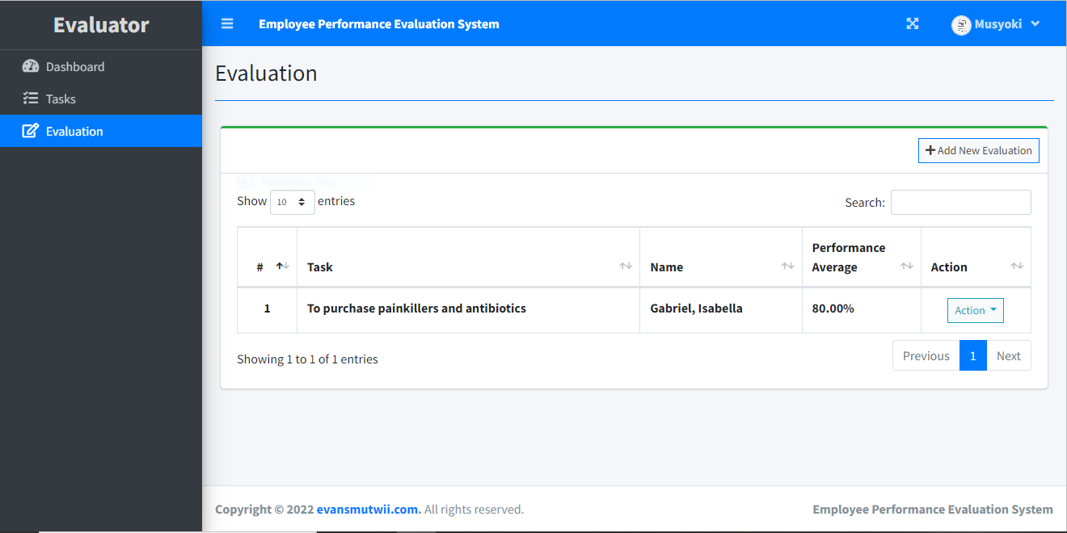

**3.3.3.2** Evaluation from the Evaluator

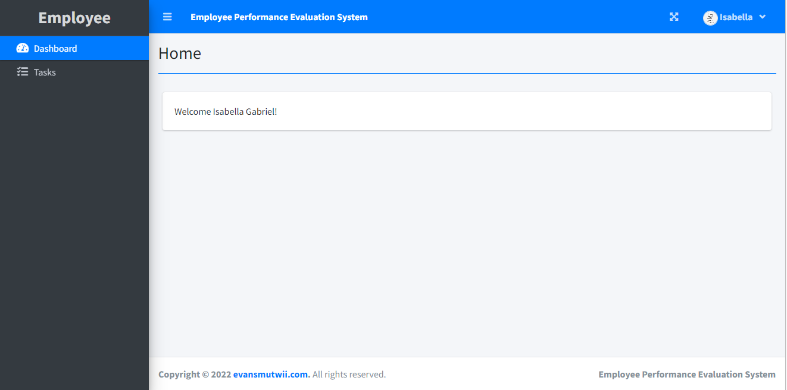

**3.3.3.3** Employee Dashboard

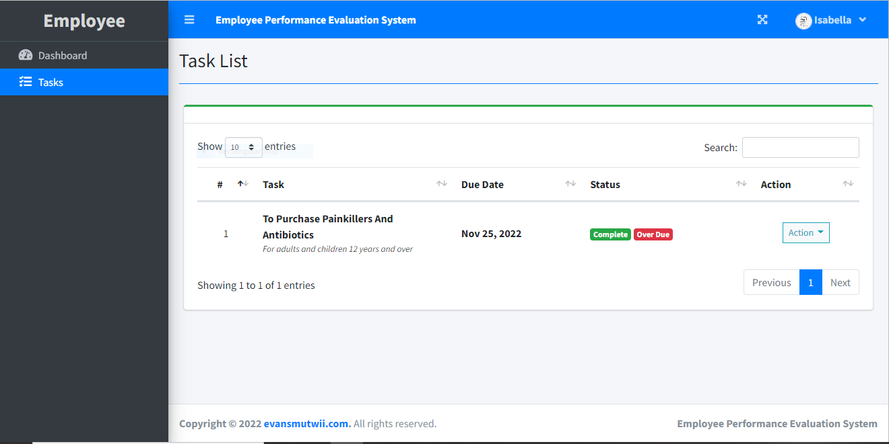

**3.3.3.4** Employee Task List

**3.4 Implementation / Development**

### **3.4.1 Language(s), Frameworks and Other Technical Requirements**

C++programming language used to generate an elaborate code for the system

### **3.4.2 Code Review Strategy**

Check the code for

* debugging before deployment
* For coding compliance standards.

The following should be conducted for code review

* Keep a time limit of 60 minutes
* Use code review checklist
* Immediately fix defects found

## **3.5 Testing**

### **3.5.1 Functional Requirements Testing**

**Unit testing**

Unit testing was carried out on individual modules of the system they are fully functional.

This was done by examining each unit. It was to checked if it is able monitor staff activities

**Integration testing**

The integration testing was carried out after different modules had been put together to make a complete system. This was aimed to ensure modules are compatible and can be integrated to form a complete working system

**User acceptance**

A test was carried out to find out users reaction towards the system and be able to know if it has made their desires

**Localization testing**

A localization testing was carried out to see if the system was fit to be established within that organization

### **3.5.2 Non-Functional Requirements Testing**

**Usability testing**

A test was conducted to evaluate the system by representative users.

**Scalability testing**

This was conducted to measure how the system software can manage user traffic, data volume

**Load testing**

Conducted to measure performance of the system

## **3.6 Deployment**

Once the system is tested and ready a training plan is conducted for staff and administrators to learn how to navigate through the system

Goals are set to complete the transition smoothly

Roles are assigned between staff and managers. Staff are required to provide personal details for record in the system database. They are required to use biometric gadgets to record time they report to work

An elaborate communication method has to be chosen to interact with the system

Managers are accountable for system monitoring, security, give authorization, make updates and implant modification on the system. Regular testing of the system under supervision of managers

# **CHAPTER FOUR: CONCLUSION AND RECOMMENDATIONS**

## **4.1 CONCLUSION**

**Info**rmation is an indispensable tool many organizations in decision making.

Digital PMS are more elaborate compared to manual system. They are consistent, less data redundancy, easy to update, good security, effective and easy to backup. An integrated PMS provides solutions to address problem associated to staff competence. The system is free from errors and very efficient. All phases of software development cycle have been employed and is worthwhile to state that the system is robust. Provision is made for future development in the system

## **4.2 RECOMMENDATIONS**

Since PMS is very broad, the scope of the project covers only small aspect of it

Organizations who are interested in building PMS should be encouraged to work on other aspects of such system in all available systems similar to them

# **CHAPTER FIVE: REFERENCES AND APPENDICES**

## **5.1 REFERENCES**

**Boipono , M, Tsomele , TG &Mogadime,R.2014, ‘IMPLEMENTATION OF PERFOMANCE MANAGEMENT SYSTEMS (PMS) IN SCHOOLS;SUCCESS FACTORS’, International journal of research in applied , natural and social sciences, vol. 2,no.2, pp.189-194**

**Jan, S, israr, M, Haq, Z.U, Tariq, M & jehangir, M 2014, ‘The effect of performance management system on teachers’ efficiency. A case study of private schools in district Peshawar’, Life science journal,vol.14, no.4, pp.79-85**

**Sharrif, A.M. 2002,Benchmarking performance management systems, Benchmarking; An International journal,vol.9,no.1, pp.62-85**

## **5.2 APPENDIX I:**

## **5.3 APPENDIX II:**

**5.4 APPENDIX III:** **GANTT CHART**

## 

|  |  |  |  |  |  |  |  |  |
| --- | --- | --- | --- | --- | --- | --- | --- | --- |
|  | **Week 1** | **Week 2** | **Week 3** | **Week 4** | **Week 5** | **Week 6** | **Week 7** | **Week 8** |
| **Planning** |  |  |  |  |  |  |  |  |
| **Analysis** |  |  |  |  |  |  |  |  |
| **Design** |  |  |  |  |  |  |  |  |
| **coding** |  |  |  |  |  |  |  |  |
| **Testing** |  |  |  |  |  |  |  |  |
| **Implementation** |  |  |  |  |  |  |  |  |
| **Maintenance** |  |  |  |  |  |  |  |  |

**Table 4.**